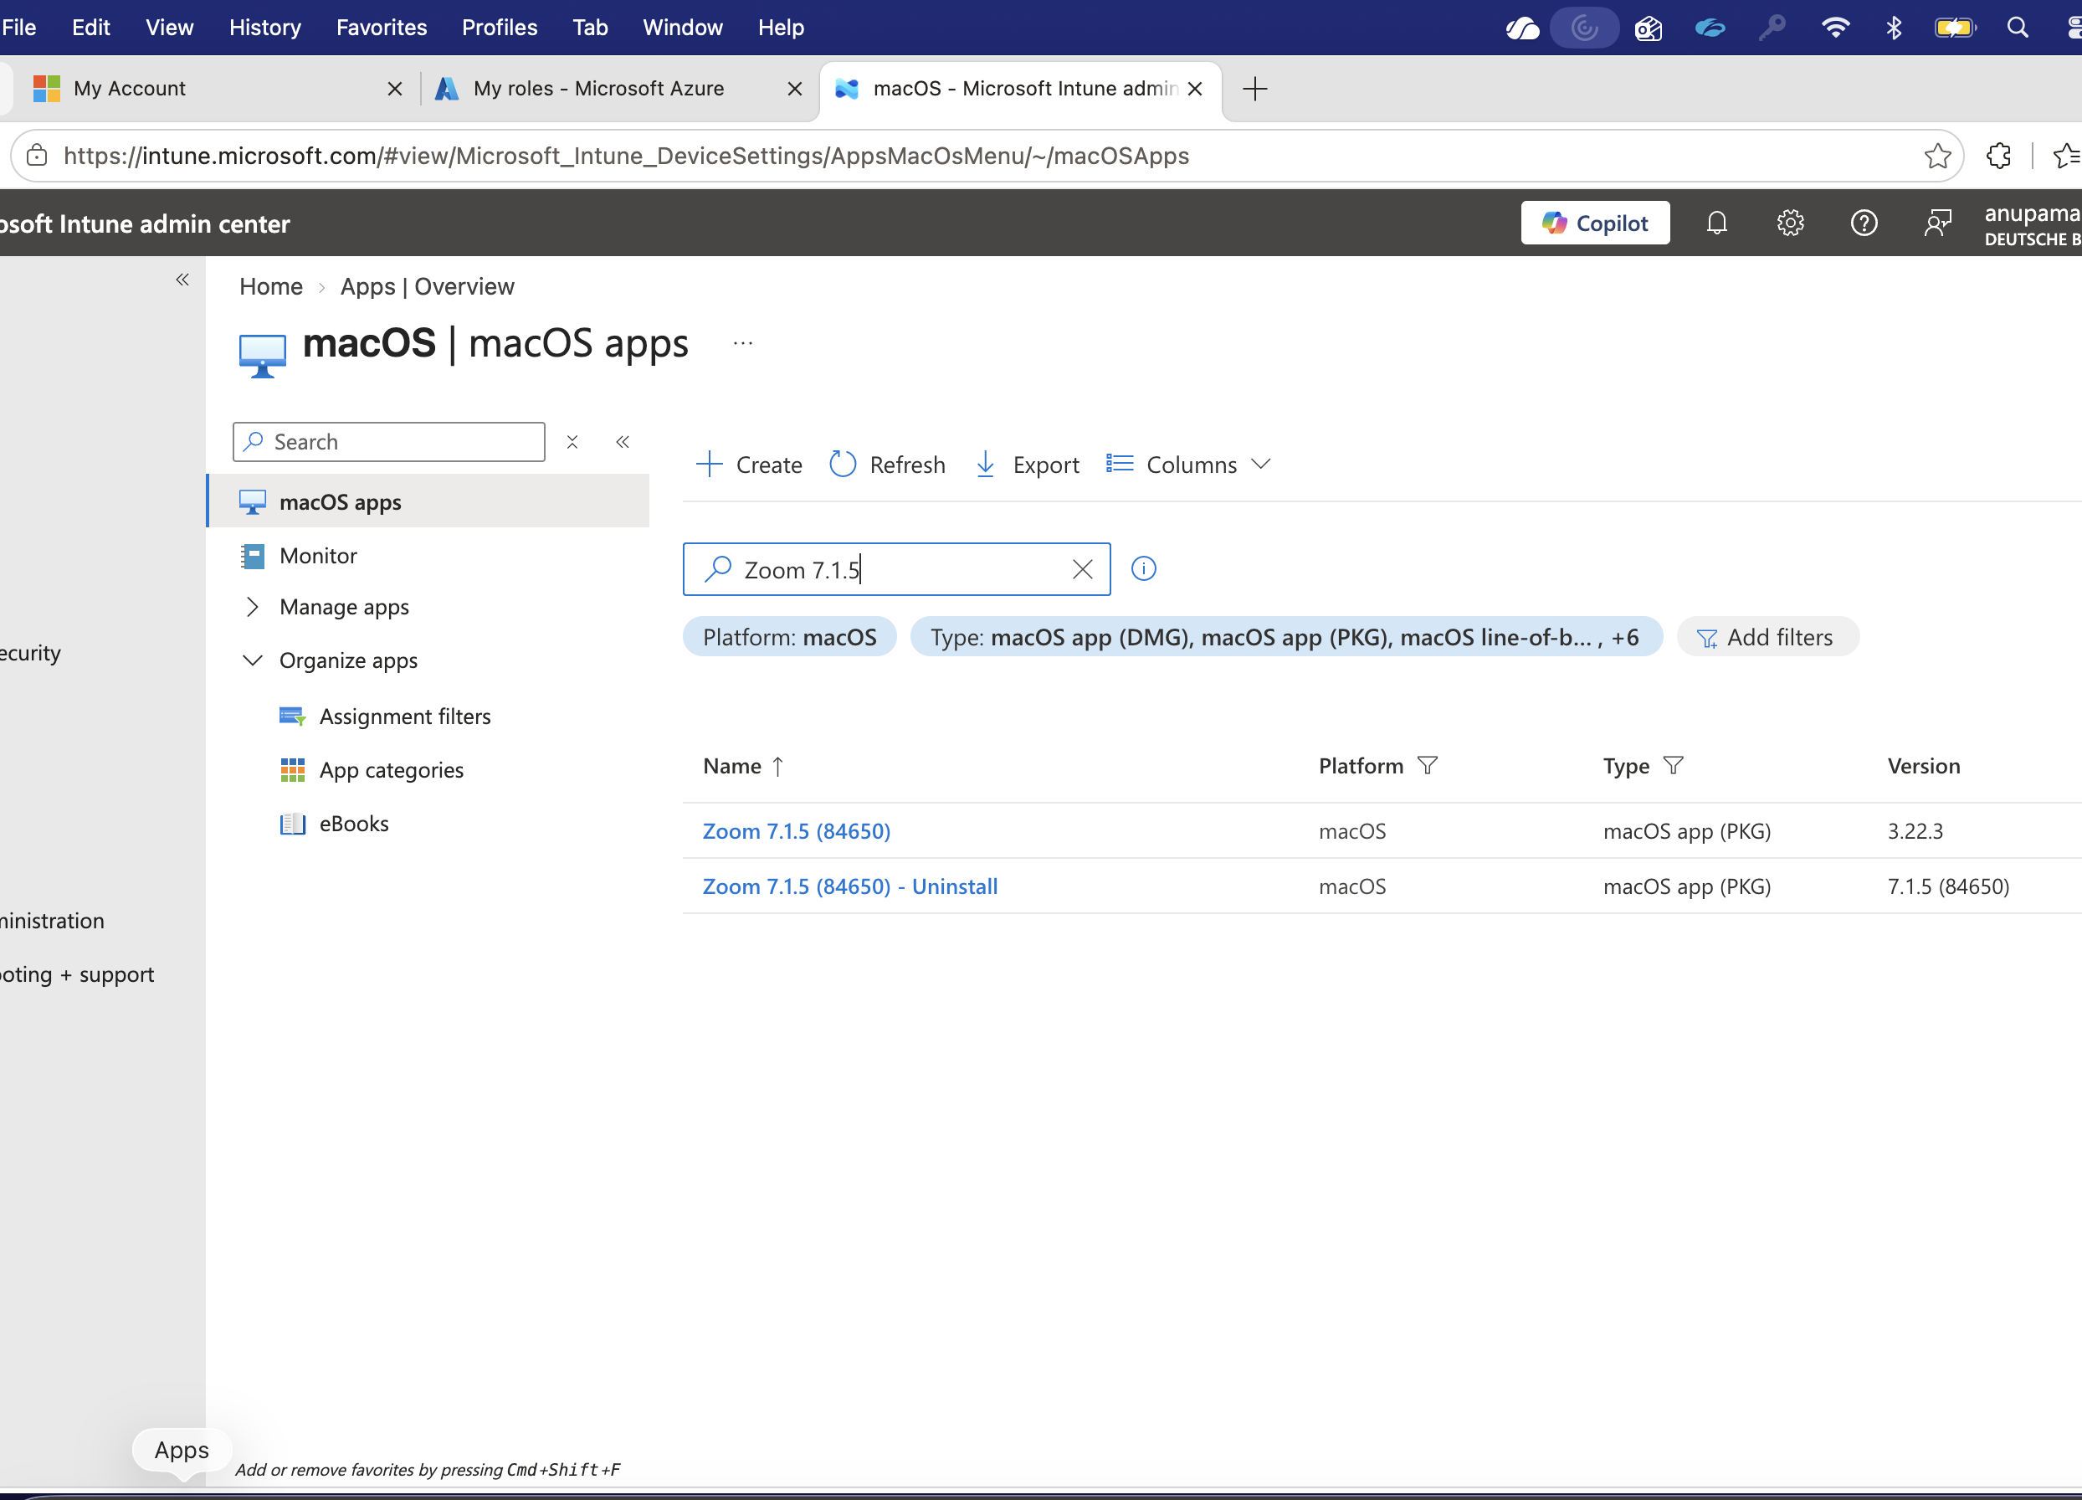

AA-SW-Intune-MacOS-Zoom 7.1.5 (84650)-Available

